**PROJECT REPORT**

Implementing CRM For Result Tracking Of A Candidate With Internal Marks - (DEV)

**1. INTRODUCTION**

**1.1 OVERVIEW :**

Result tracking of a Candidate is a type of salesforce software that is designed to help educational institutions manage the results of their students. It automates the entire process of result management, right from the creation of exam schedules to the publication of results. The software allows for easy and efficient management of large amounts of student data, including their personal information, enrollment details, and academic performance.

**1.2 PURPOSE :**

The purpose of the software includes data backup in case of unforeseen events, data security against unauthorised access and cyberattacks, data retention, data access control, data classification, and compliance with all legal procedures are all provided.

**1.3 PROJECT DESCRIPTION :**

All basic data, such as the semester, candidate, course, and lecturer, should be able to be created by the administrator; however, only the lecturer, who also happens to be the dean, should be able to amend the internal results. Re-evaluation Candidate has the ability to initialise all Internal Results. Following a second evaluation, only the dean is now able to update the grades.

**2. CANDIDATE INTERNAL RESULT CARD:**

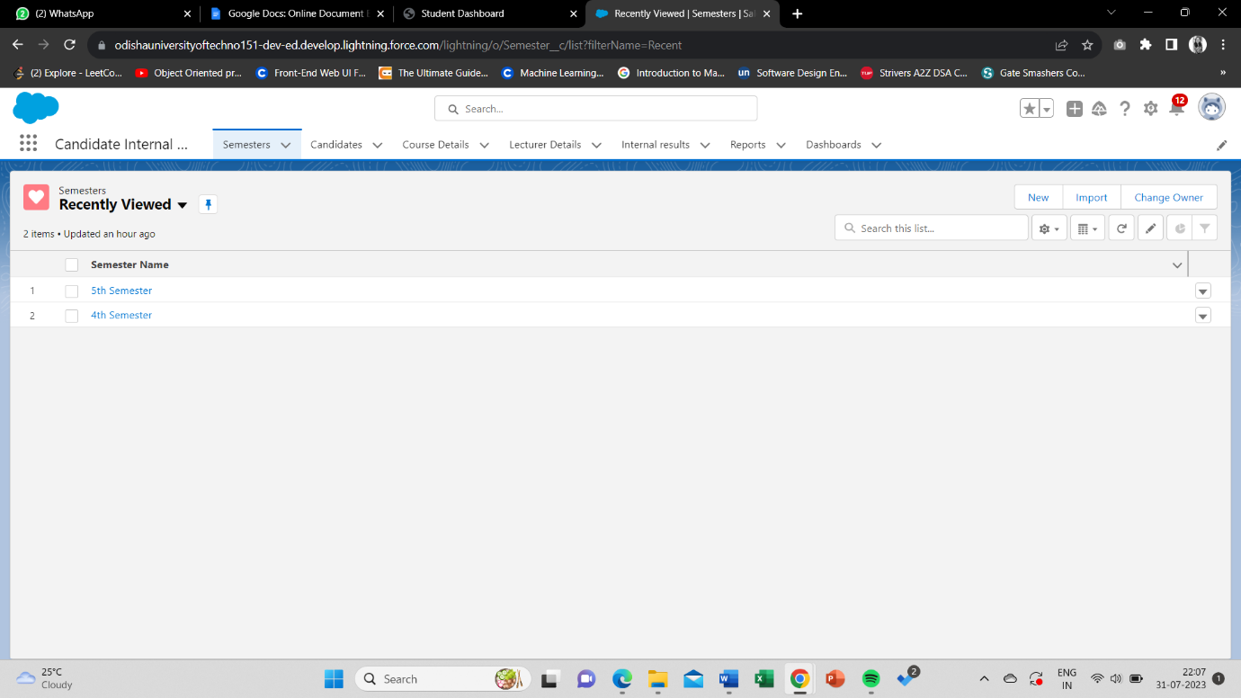

**3. FIELDS & RELATIONSHIPS :**

* 1. **Activity given :**

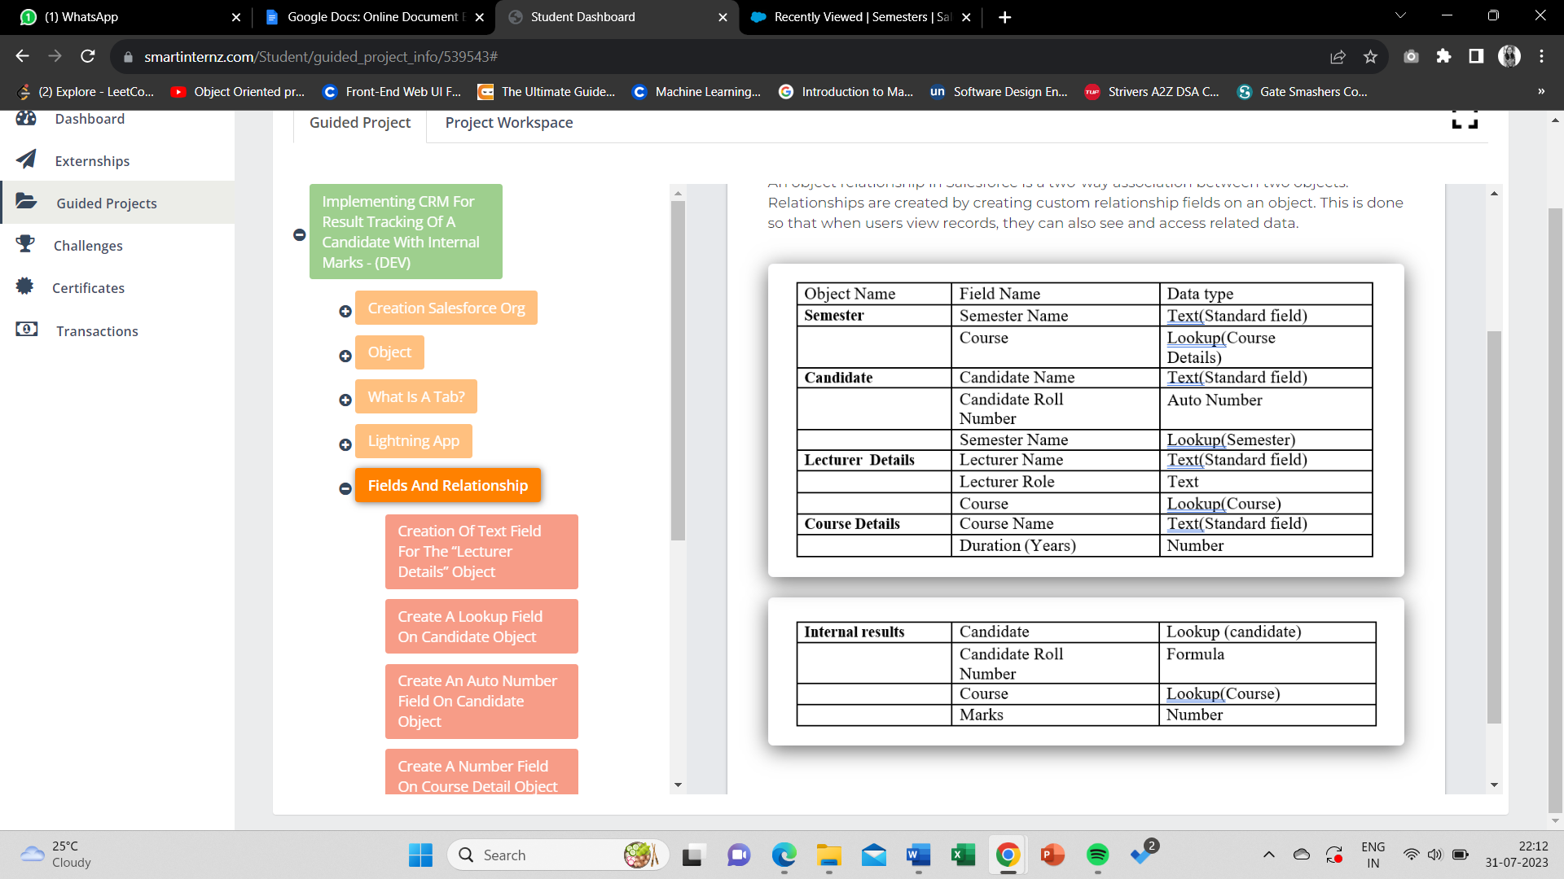

* 1. **SCREENSHOTS**
     1. 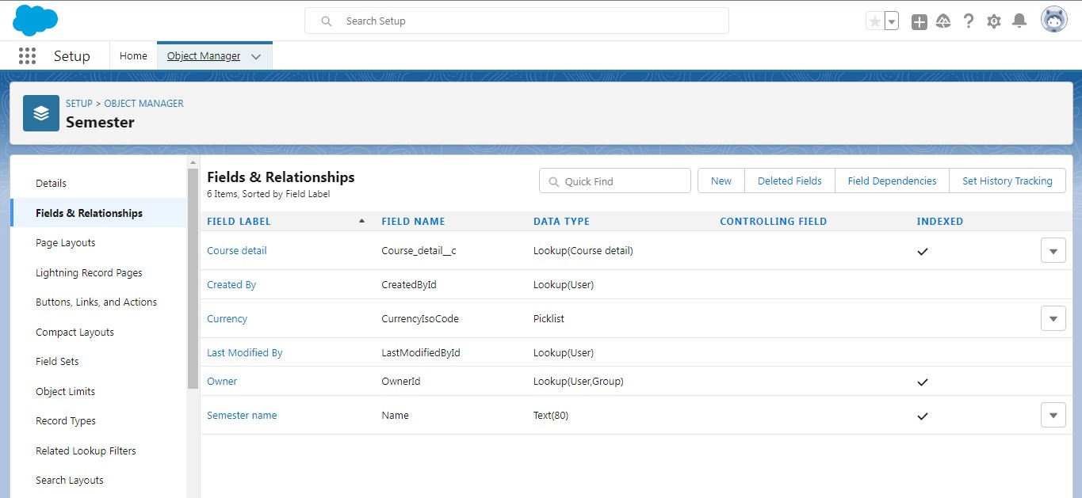**Semester Object**

**The fields for Semester Object are created.**

* + 1. 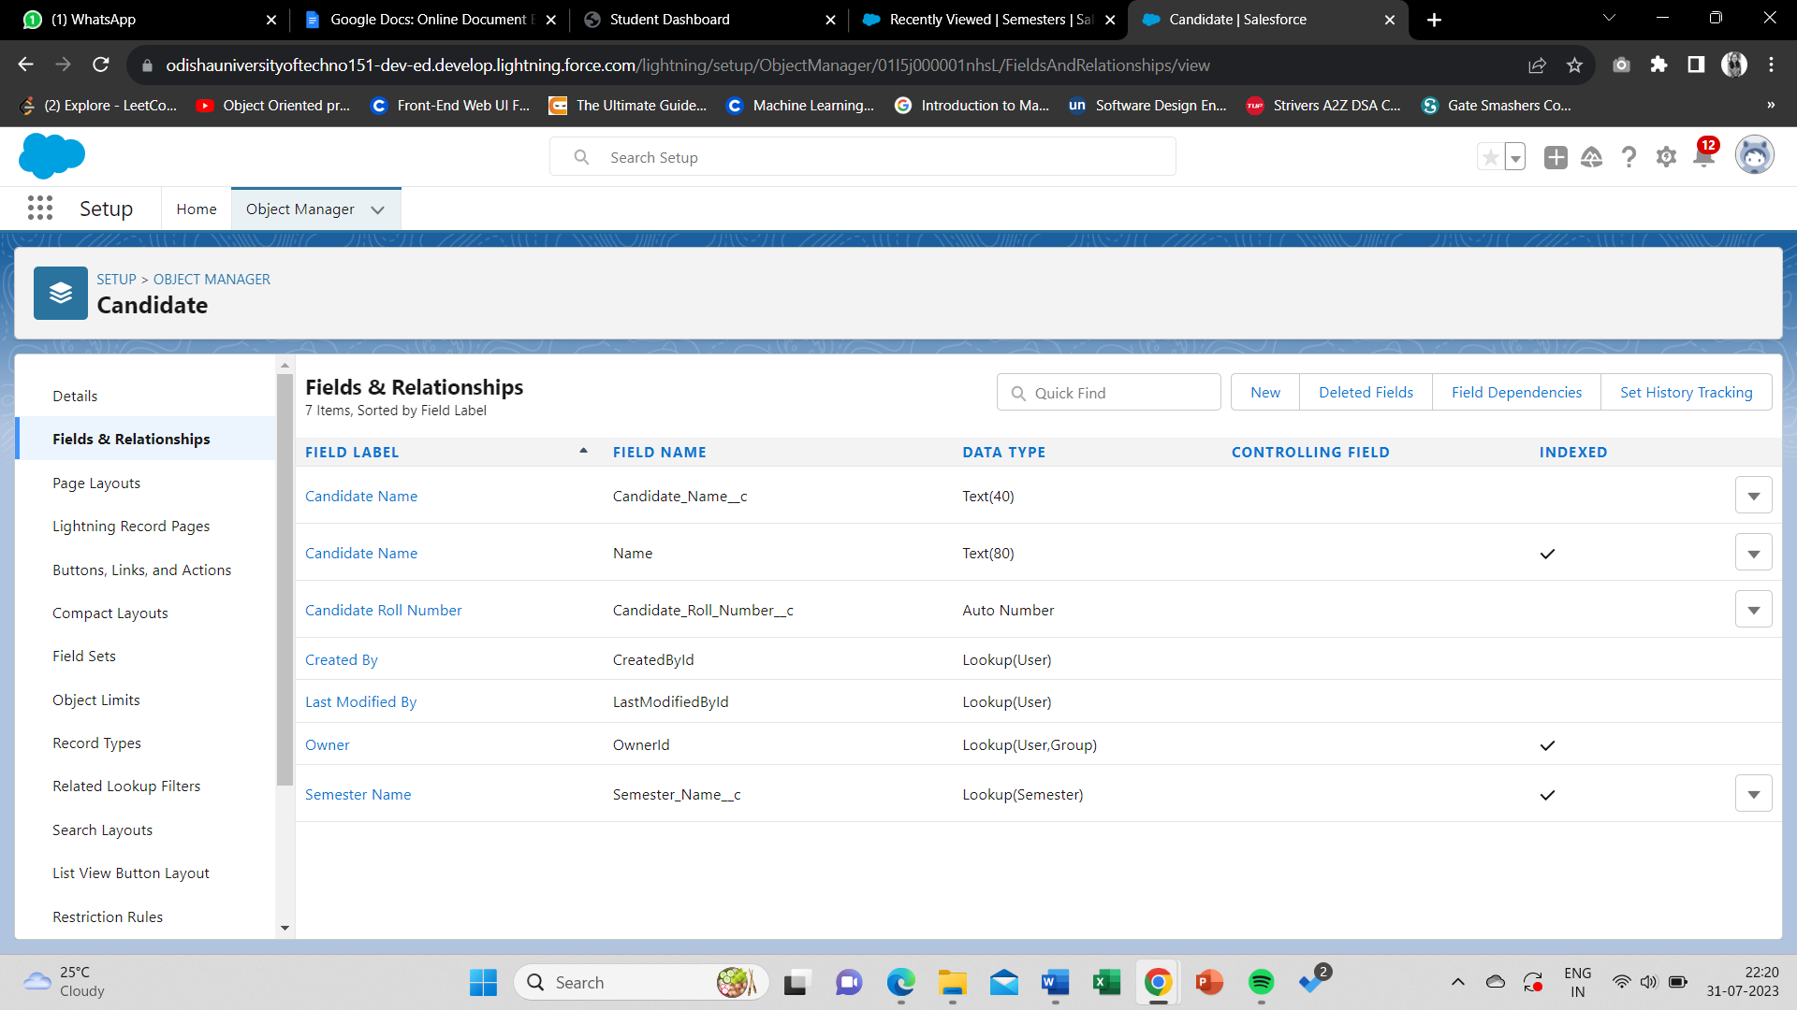**Candidate Object :**

**The fields for Candidate Object are created.**

**.**

* + 1. 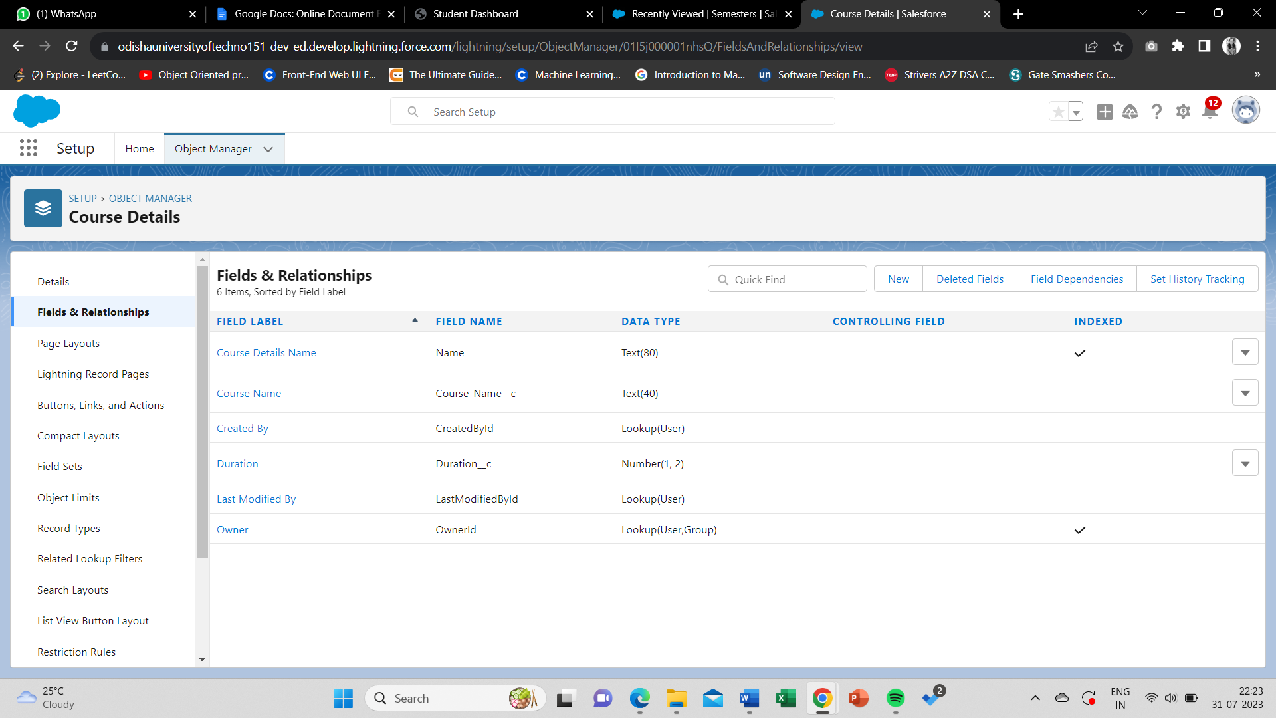**Course Details Object:**

**The fields for course details object is created.**

* + 1. 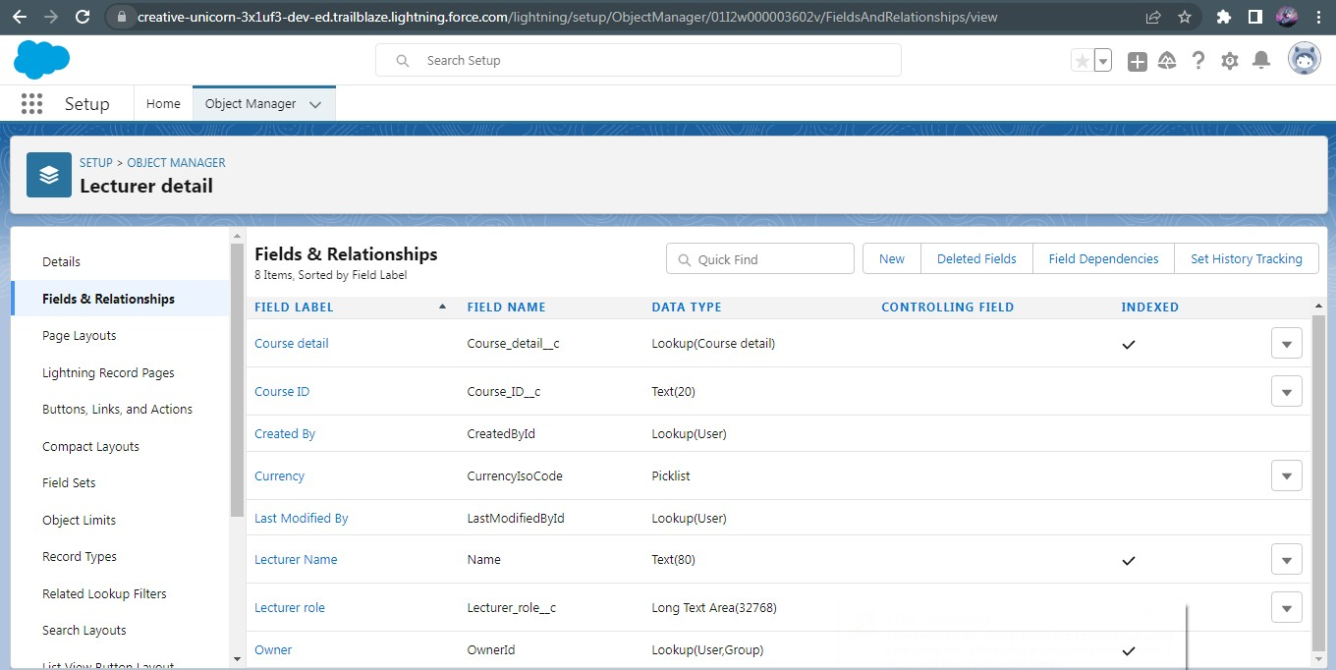**Lecturer Detail Object:**

**The fields for Lecturer details object is created.**

* + 1. 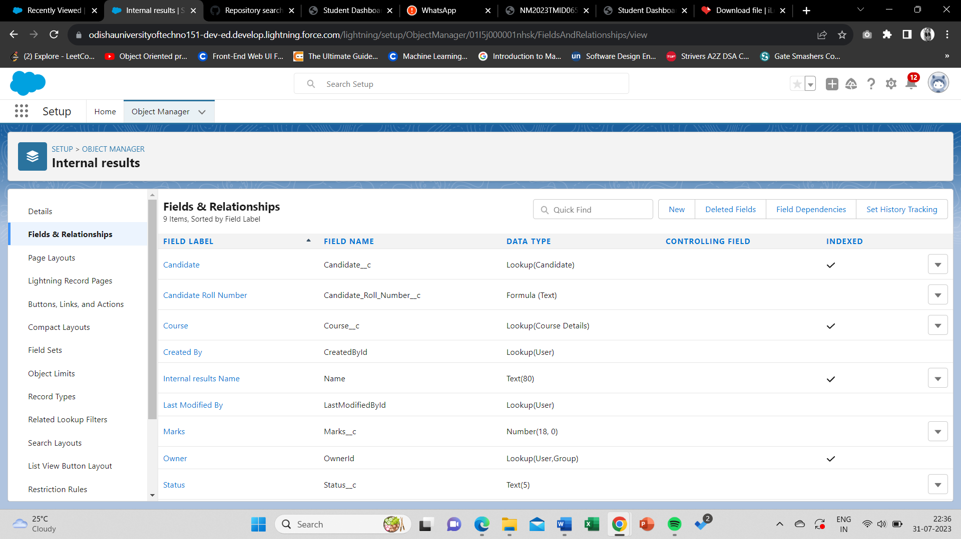**Internal Marks :**

**The fields for Internal Marks object is created.**

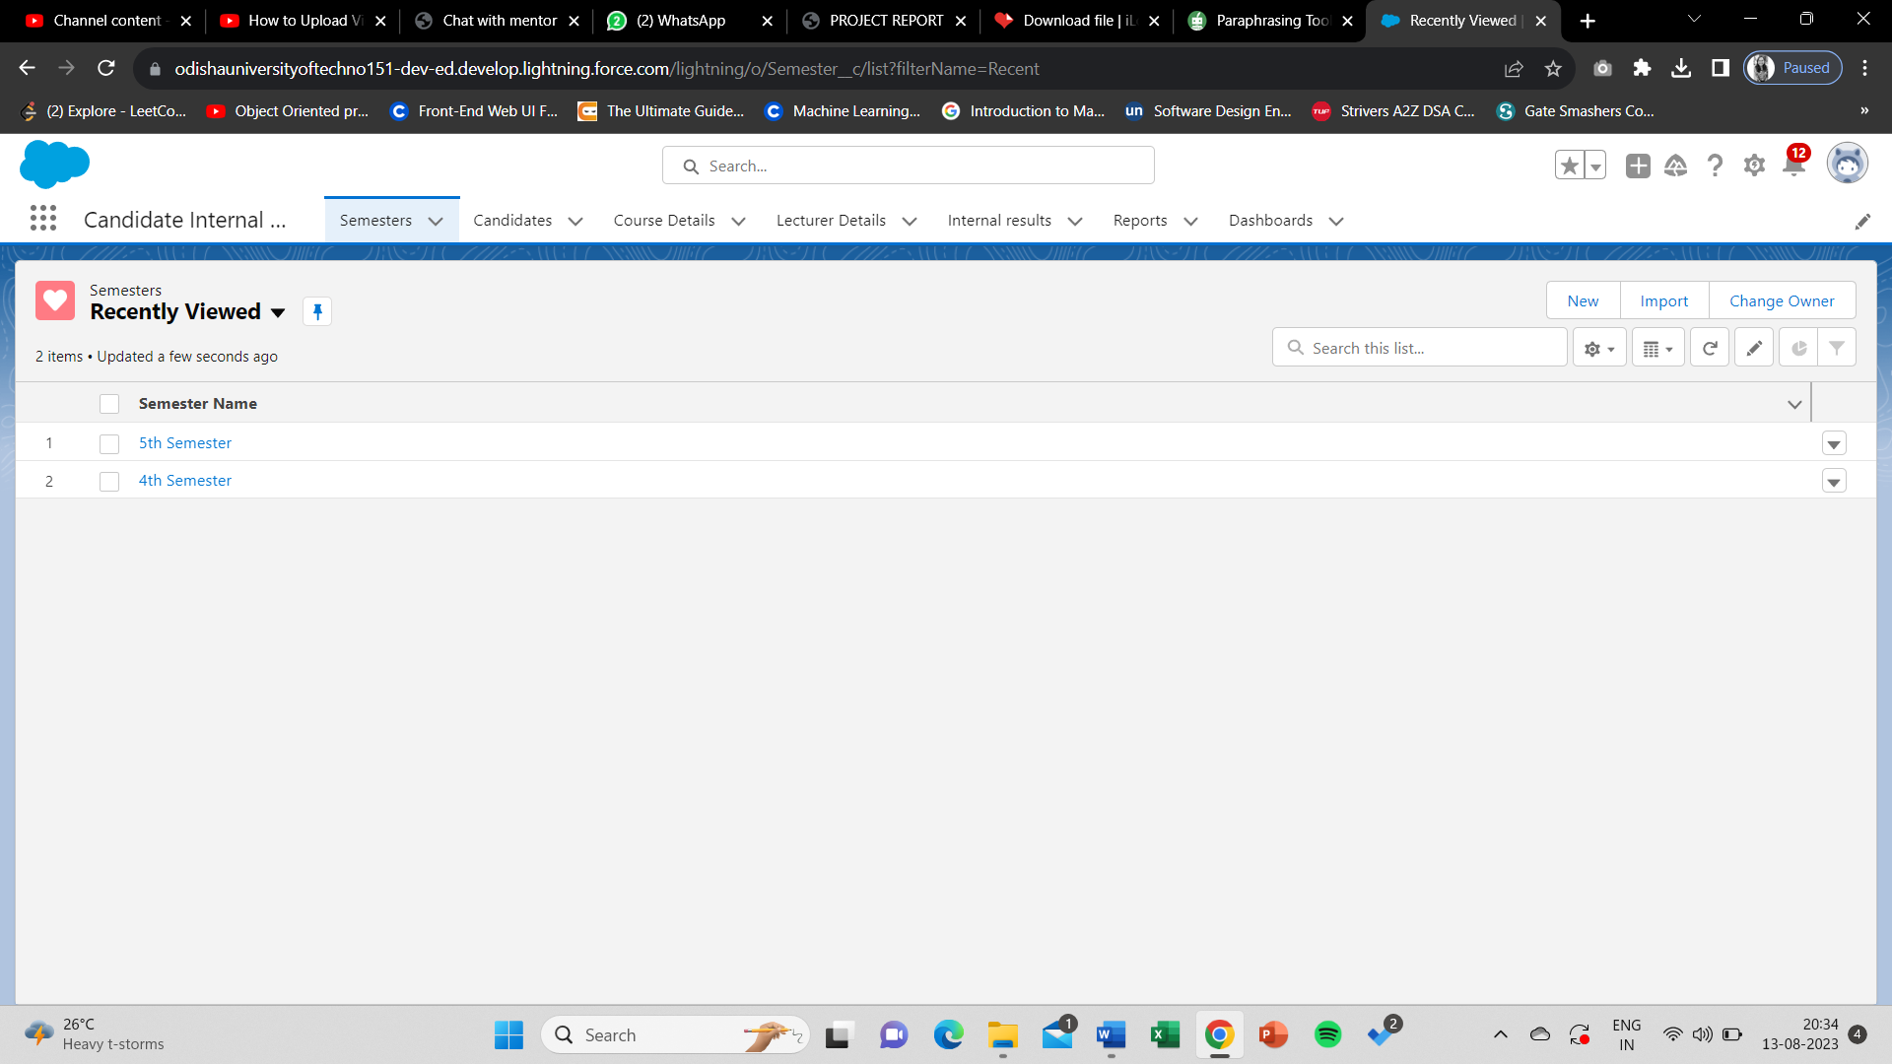**4. CREATION OF TABS :**

**All required Tabs are created.**

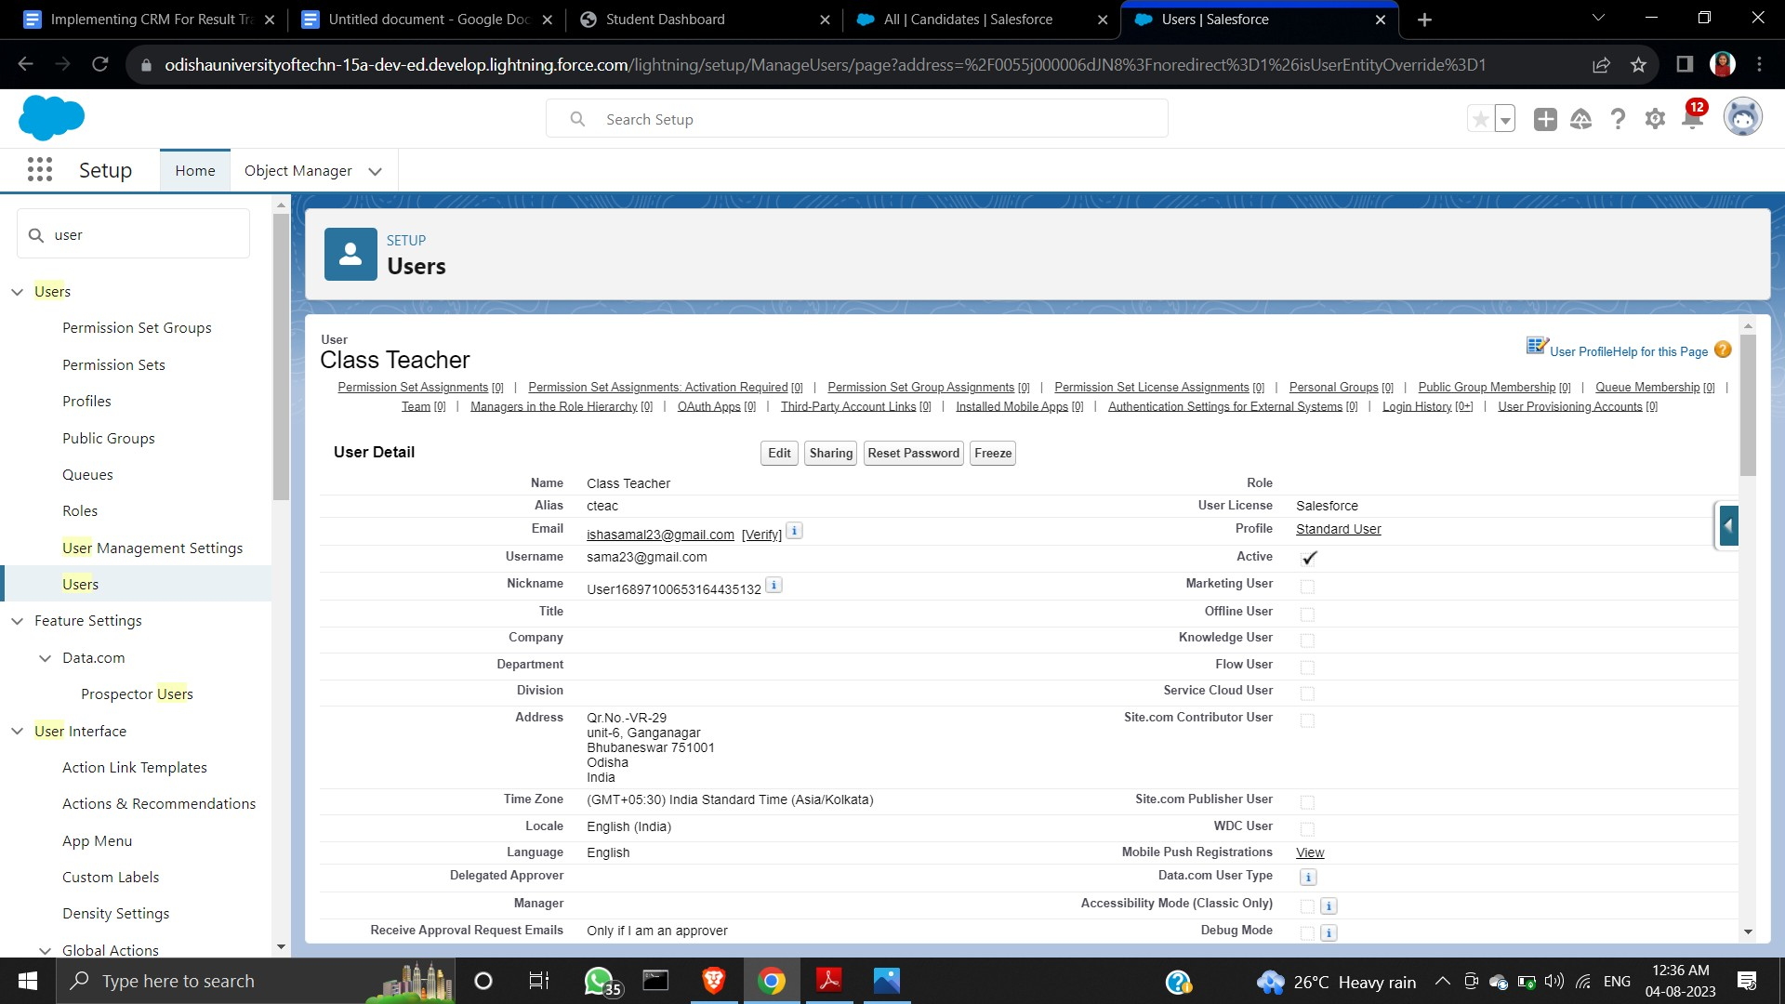**5. CREATION A USER**

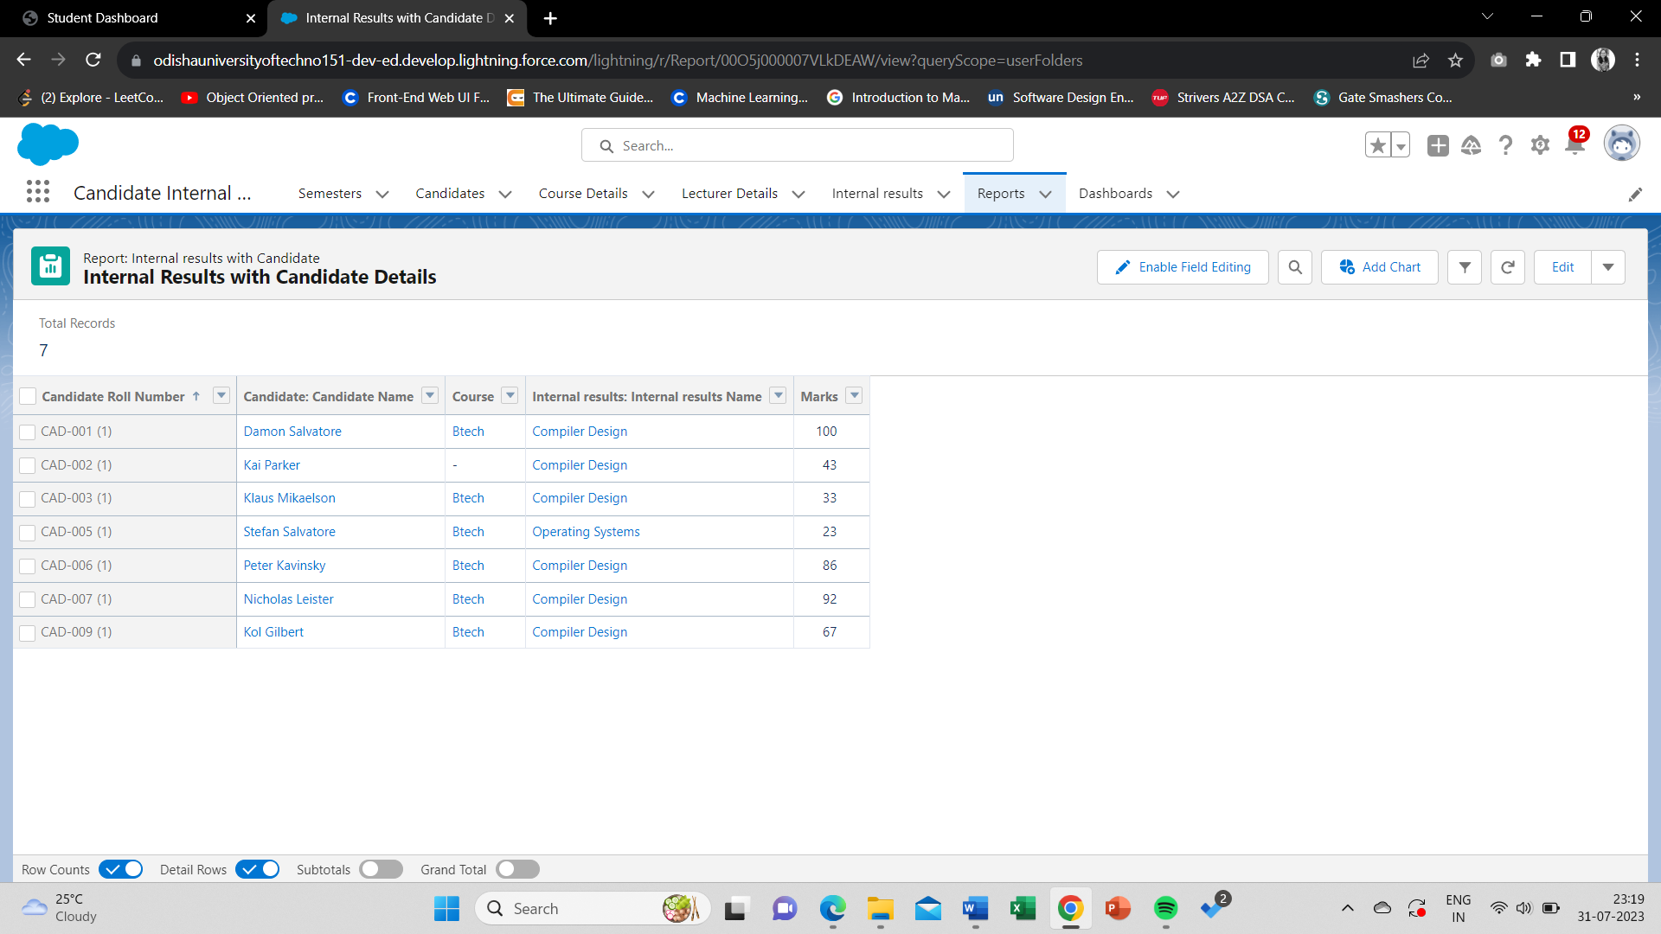**4. CREATION OF REPORT :**

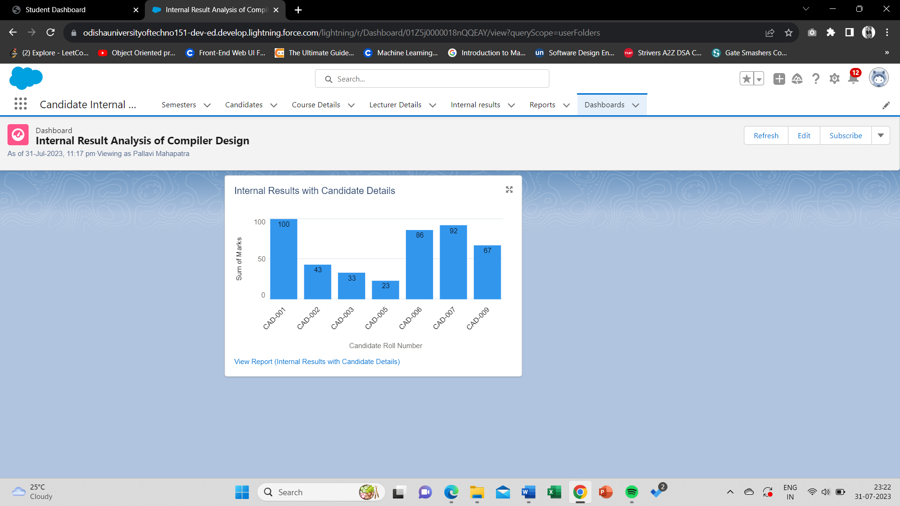**5. CREATION OF DASHBOARD :**

**Internal Result Analysis Dashboard**

### 6. CREATION OF FIELD UPDATE USING TRIGGER

**Apex class named as InternalmarksHandler**

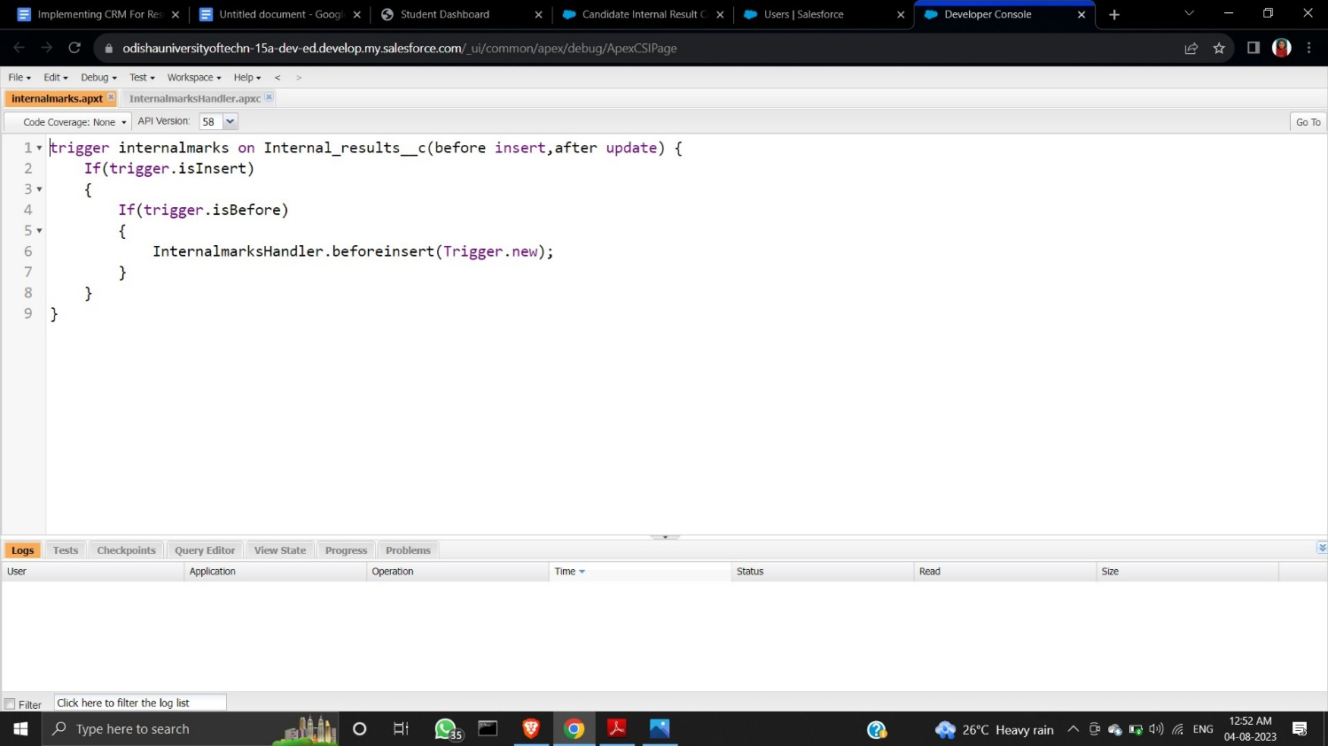

**Apex trigger named as Internalmarks**

**7. TRAILHEAD PROFILE PUBLIC URL**

**Trailhead ID:** [**https://www.salesforce.com/trailblazer/pmahapatra19**](https://www.salesforce.com/trailblazer/pmahapatra19)

**8. ADVANTAGES**

* Provides a secure environment for storing and managing student data.
* Offers performance analysis to identify areas where students need additional support.
* Improves communication between students, parents, and faculty.
* Enhances the overall quality of education.
* Elevates the holistic standard of education.

**9. DISADVANTAGES**

* To utilise the software efficiently, one must receive the necessary instruction and training.
* The cost of implementing result management software varies.
* Results processing might be delayed or affected by technological problems like system failures or software flaws because result management software can be complicated.

**10. APPLICATIONS**

* The result tracking salesforce software facilitates easy communication between teachers, parents, and students by enabling them to access their child's results, attendance, and other information online.
* It can also help identify areas where students need additional support and enhance education overall.
* The programme can enable student evaluation and feedback, allowing teachers and administrators to gauge student satisfaction and pinpoint areas in need of improvement.

**11. CONCLUSION**

A CRM system that uses Salesforce to track candidate outcomes, including internal marks, provides educational institutions with a game-changing answer. This project enables enhanced student involvement, well-informed decision-making, and a higher quality educational experience by streamlining result administration, enhancing communication, and offering analytical analytics.

**12. FUTURE SCOPES**

• In the medical field, result management software can aid specialists in keeping track of patient information, test results, and medical records. Additionally, it can increase the efficiency and precision of diagnosis and therapy.

• In the public sector, result management software can assist in ensuring the accuracy, transparency, and accessibility of public data, such as polling or election results.

• In business, result management software can assist organisations in managing performance measures, sales data, and customer feedback.

• In sports, result management software can assist coaches and trainers in monitoring the development of athletes, coming to informed judgements, and enhancing performance.

• Result management software helps speed up the research process, increase accuracy, and help researchers organise and analyse data more effectively.